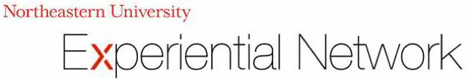

COP5003 Final Project Report– Winter 2018

Project Sponsor: Michael Radice

Project Title: Robot Kiosk Design

Project Members:

Jhansi Nair

Kushal Ramdharne  
Sami Ranjan Shekhar

Alisha Atreja

Meet Patel

Reuben Mathew

**Background**

Robots as human test machines have evolved drastically in past few years. Starting from the first robot created in Germany in 1810 to present day, they have played a significant role in replacing human beings through technological revolution. Robots have entered almost every field trying to take up our repetitive or dangerous work in different forms. Apart from the remarkable functioning of intelligent system what interests us more is the Robot’s physical appearance that has also changed over the years. This aroused a need for a robot kiosk, a process that helps a robot look like a human, perform functions like human and is as interactive as a human to connect and reach out to more masses. Below is the image of one of the oldest robot’s and we can see how they have progressed over the years.

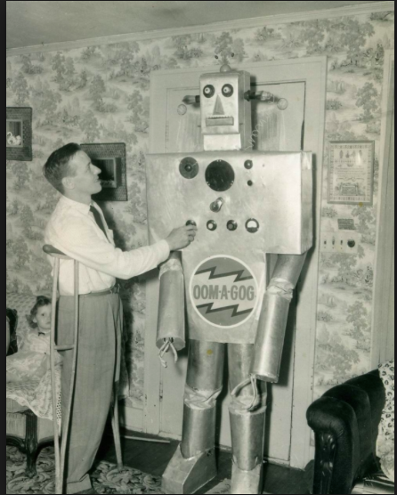

Image Source: Google

**Objective**

The purpose of our project is to design and cost-out a kiosk for NAO robot that can navigate around the Information desk/reception area. We plan to do this by keeping robot’s features intact and by enhancing robot’s physical appearance and customer friendly multifunctional service through this kiosk.

**Abstract**

When we design a social robot, the biggest thing that we have in our mind is the physical appearance of the robot and that it should be matched with its intended function because it can create a bias towards the behavior of users and their expectations towards the robot. The robot’s similarity to humanness affects familiarity that the humans look for.

**Market Analysis**

Kiosks have taken over the market and their demand has increased significantly because of the embedded technological advancements. They serve as the best way to reach out to multiple audience through their accessibility to different locations. The first and foremost objective of a kiosk company is to increase its market sales. According to the results of a study found on the internet, revenue for kiosk market in United States was $2.5 billion in year 2015 and is expected to go up to 30.53 billion i.e. up by 6.2% by year 2024. The use of kiosks has been since in many fields such as banking, retail, financial services, healthcare, entertainment, aviation etc. ranging from self-service kiosks to vending kiosks.

Among these retail and healthcare sectors have outshined in raising up the revenue. Progress in retail sector is presumed to go much faster than in healthcare sector. The dominance of Kiosk US market than other markets is the booming US technology.

The most accepted pricing model is the kiosk unit-based pricing. It helps make low upfront costs and provides an access to add units whenever need to price rise arise. It also allows purchasing customers to have a control on kiosk customizing per their needs. In this way, the purchasing customers do not have to pay for unnecessary features.

**Market Feasibility**

The kiosk is aimed at serving an individual robot, and the market feasibility would depend solely on the client company responsible for the robot, and the various factors affecting the lifetime of the robot. We believe that as long as the robots have a high demand, the demand for the kiosk will be high, and matching that of the robot.

Further, there are increasing number of organizations that are investing in creating such automated solutions for customer service and interaction. We believe that the successful completion of this project would lead to a lot of new opportunities.

**Designing of the Kiosk**

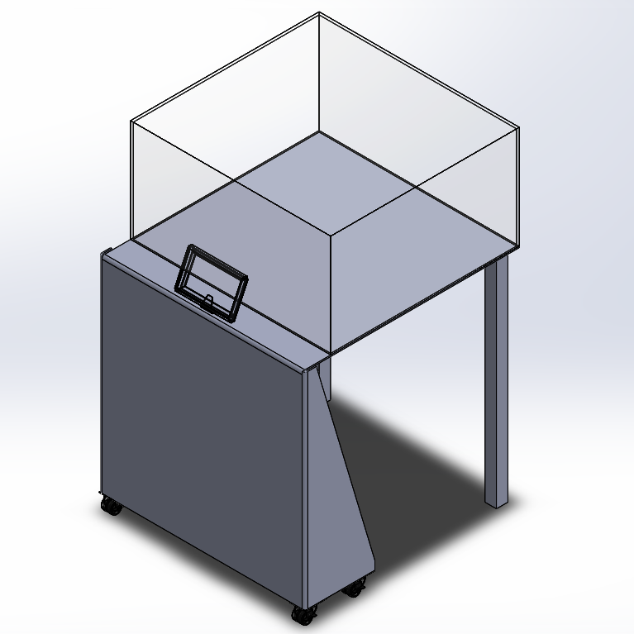

Isometric View

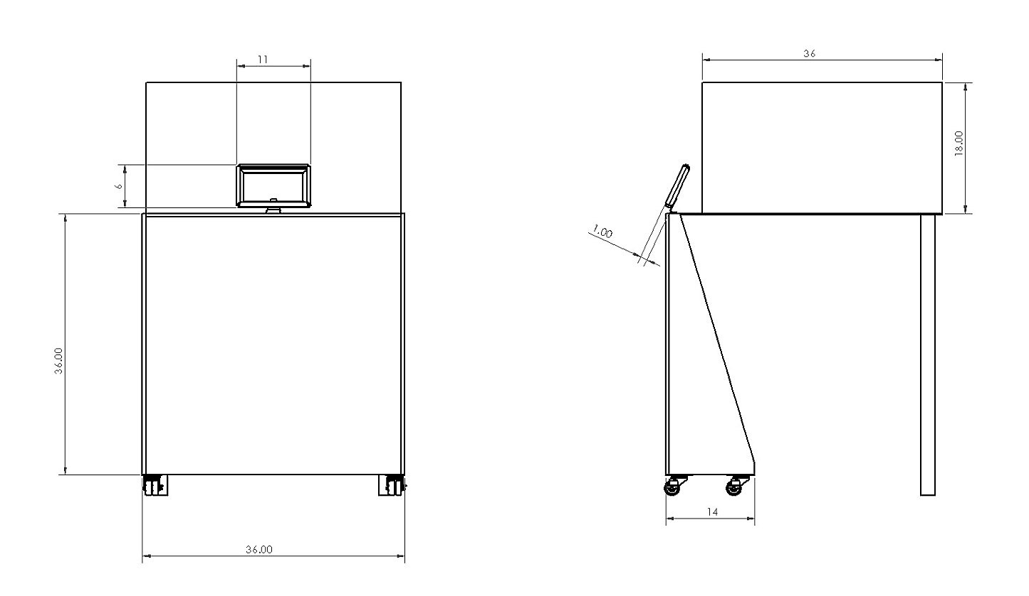

Front view Side view

**Kiosk Design Description:**

* Kiosk setup when completely folded will be of size (36” x 36” x 14”). Back panel of the kiosk will have a moving hinged aluminum plate which when opened will act as a platform for Robot.
* Setup consists of a slanted tablet mount of size (6” x 11”)
* Kiosk will be manufactured using Anodized aluminum
* Kiosk design includes shelf inside kiosk to store network router and battery packs.
* Robot stage – A foldable Anodized aluminum platform with detachable walls made from four separate pieces of plexiglass that can be put in place in holding slots around the edges of the stage platform. Plexiglass walls can be stored inside the kiosk when not in use.
* Stage will be supported using Adjustable-Height Folding Table Legs
* Lockable wheels for kiosk

**Design Considerations**

**1. ACCESIBLE COMPUTER SCREEN**

There are many accessibility features available depending on the needs of customers.

Technical features:

* color contrast on the display screen to make it look more interactive
* audio and video instructions
* voice-activated equipment for ease of use

Structural features:

* height and stability of the kiosk (Keeping in mind a user with a disability)
* headset jacks with on screen volume control
* specialized keypads or keyboards (e.g. tactile keyboard)

**2. KIOSK COMPUTER**

There are certain features that had to be taken care of since the interactive computer should not only be accessible and interactive but also robust.

* ***Operating Conditions***: They should operate in a wide variety of conditions. Also, they should consist of a feature to turn themselves off when the conditions get too bad before they damage themselves.
* ***Video/ Audio performance***: It has to be ensured that the output is clear and enhanced. The response rates should be quick so that the user finds it interactive. A dedicated GPU could come in handy here.
* ***Memory***: Hard drives are important so as to store the information of the user. For example: A medical ID of a patient, sleeping patterns of a kid for the parents to access. A solid-state drive could be provided which would be fast enough for the data to be transferred or stored.
* ***Power supply***: This is the most important aspect in a kiosk system. A reliable power source is required so as to make sure that the integrated components are fully functional at all times.

**3. COMPONENT INTEGRATION**

The wide demand of KIOSK and its dominant market share has led to the production of custom designs that serve different users and the environment that it is intended to be used in. So, there can exist a custom design, with just a few unique components that have been economically integrated together to serve the purpose. Some of the most usable components that could serve as a part of commonly used kiosk systems:

* The LCDs size can vary and it depends on the user.
* Card Readers to make payments. (Both swipe and insert feature)
* Printer associated (photos in case it is used as a learning device for a child)
* Biometrics: Thumb prints, iris recognition for added security
* Bar Code/Document Scanners
* High quality web cameras
* Privacy and Security – Hidden laptop, Retractable Printers, Cash Box Safes, Locks and alarms
* Wireless - Routers, Bluetooth / Infrared, Wi-Fi

**4. HIDDEN LAPTOP**

The automated laptop kiosks help in not only securely storing personal data but also keep a self-check via an automated program to make sure that the kiosk is running smoothly and ensure complete performance.

There are certain features that the windows platform offers to make the kiosk secure and allowed access can be modified by the administrator is provided only as per needed

* Allowed Access

This feature helps to create a user account which only allows to launch a single application and work on it. This is a much better option since turning the entire computer in the lock down mode is not preferable.

* Windows Enterprise customizations

This feature can help provide a controlled and specialized experience. This enables the system administrators to create a lock down; limiting the device interaction experience. This can help narrow down problems that are caused due to misuse or malicious users. This lockdown can be done individually or in combination providing a custom defined user experience and thus increasing system reliability.

**5. PROTECTION**

Materials that can be used for the protection can be:

1. Plexiglass Acrylic Sheets:

Plexiglass can be cut with a fine-tooth jigsaw blade or a carbide-tipped tools. Also, plexiglass is available in rod, tube as well as sheet form. A large one single sheet could be used for the robot and the compartments for wheels should be cut into it. Plexiglass Acrylic Sheets have certain advantages that make it the *best alternative*.

* It is formable so with little heat, it can be molded in the desired shape at very low temperature which makes them economically viable.
* It is extremely durable and robust
* Under bad weather conditions it can easily withstand and is much more reliable than other plastics
* Varying levels of heat resistance, transparency, strength are available to suit the needs
* Also, as an added advantage the color does not fade off(non-yellowing)

In addition to these, Plexiglass also has

* Very high bonding properties with reactive adhesive which in turn makes the whole structure made from it very strong at joints.
* Have approximately 1.18 g/cc of density which is similar to polycarbonates and acrylic.
* Water absorption is about 3% by weight which makes it more water resistant than most of the other options and thus better protection to short circuit.
* Better scratch resistant than polycarbonate.
* More dent resistant than polycarbonates.
* One of the most important property is better resistant to abrasive cleaners when compared to polycarbonates.

1. Polycarbonate Sheets:

Polycarbonate sheets can also be considered as an alternative to plexiglass acrylic sheets for the following reasons:

* Better impact strength than plexiglass.
* Better flexibility than acrylic which makes them easy to mold.
* Polycarbonates along with certain additives can withstand temperatures upto 240 degree Fahrenheit.
* Much safer to use with respect to plexiglass because of low flammability.
* But it develops yellow ting over time.
* Maximum impact strength at minimum thickness

Polycarbonates too, are available in sheet form which can easily be molded to get particular design at lower cost in comparison to plexiglass.

1. PETG Sheets:

PETG stands for Polyethylene Terephthalate-Glycol modified also can be considered as a material for protection because of following properties:

* Impact strength of PETG is 70% of polycarbonate but is stronger than plexiglass.
* Water absorption is only 0.13% which is much better than plexiglass and polycarbonate.
* Temperature withstand is close to 180 degree Fahrenheit
* PETG can be bonded and machined but difficult to polish
* Tendency of developing yellowness over time.
* Better cleansing agent resistant than polycarbonate but not as good as plexiglass.
* Density ranges from 1.2-1.27 g/cc.

All these 3 materials can be considered for the protection because their properties and applications are much similar to each other. But based on cost comparison, polycarbonate can be more expensive (Approximately 30% more costly than plexiglass) than other two.

**6. MOBILITY**

Design and type of wheels of the kiosk depends on number of factors, most important being the direction of movement where we can have,

* *Holonomic motion* – Motion is possible in every direction.
* *Non-holonomic motion* – Motion is constrained in certain directions.

Various types of wheels that can be used from simple to complex structure are listed below:

1. Caster wheels with swivel connections

* Simple caster wheel can be used when you need only back and forth movement. But when we add swivel connection to it we can have movement in multiple direction.
* We can have an addition double locking system to the wheels which can help the kiosk to be locked in a place.
* But usually these wheels have lower weight carrying capacity because the system is based on bearings.
* They are very easy to program.
* Wide range of options are available like centered orientation or off-centered orientation and thus can be adjusted and selected according to final kiosk design.

Following options can be considered if the kiosk requires multi-directional motion:

1. Omni wheels

* Omi wheels are normal wheels with rollers attached to it at circumference with the help of which they can move sideways without changing the direction of wheels.
* Lower resistance when compared to mecanum wheels.
* Omni wheels are cheaper than mecanum wheels.
* They are light weight and easier to implement.
* Diagonal movement is possible

But on the other side when compared to mecanum wheels,

* They are more power driven because they need more power to function with two different set of rollers.
* Too sensitive to non-smooth terrain which makes their use limited.
* Generates low torque and thus difficult movement

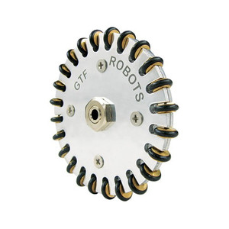

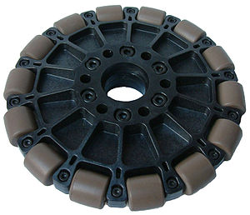

1. Mecanum wheels

Mecanum wheels provide robot designers to incorporate enhanced mobility since it supports movement in all directions. Even when the wheel is fixed this can be achieved since the direction of the individual wheels can be controlled.

Each wheel is powered by a different motor connected to the power source. Once we change the directions the wheel spins and the robot is able to move in different directions.

This is how a mecanum wheels look like:

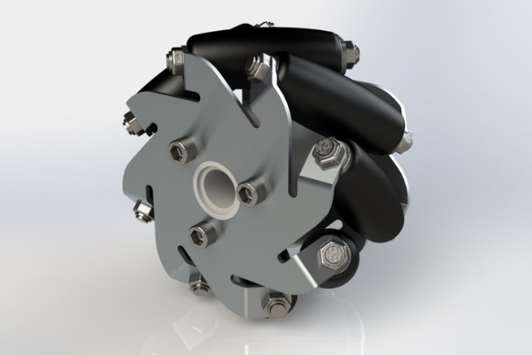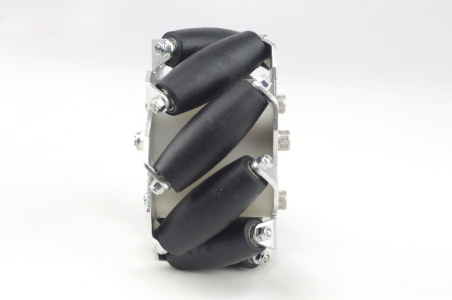

A mecanum wheel consists of many small rollers that are arranged in a forty-five degrees formation. When the robot moves and the wheel rotates; either forward or backward, the mechanism is such that it performs a rotation around its axis, each time another roller is in contact with the surface. Even if the wheel isn’t rotating, side movements are still possible as these rollers can rotate independently.

**FEATURES**

* Each wheel can be driven individually
* Separate motors for each wheel
* Omnidirectional transfer ability
* High load capacity
* Excellent flexibility

The best movement could be provided if we support the carrier with 4 wheels (which we suggest so that better locking can be done). Motion can be controlled by setting the direction, speed and the direction of the rotation of each wheel. This can be wirelessly controlled. Also, the wheels can be locked at any place.

**Locking Mecanum Wheels:**

1. A disc brake can be put just below the rollers

2. An air cylinder with space provided for the stroke to apply brakes. The air cylinder pushes and applies force against the disc brake. That wedges against the rollers to hinder the movement. The rollers are then no longer able to rotate and then it locks.

**Material Cost**

* 6061 Aluminum Plate:

|  |  |
| --- | --- |
| **Size (inch)** | **Cost ($)** |
| 36 x 40 | 128.11 |
| 36 x 36 | 116.35 |
| 14 x 36 | 57.38 |
| 14 x 36 | 57.38 |
| **Total Cost** | **$359.22** |

* Plexiglass Sheets:

|  |  |  |  |
| --- | --- | --- | --- |
| **Size(inch)** | **Cost ($) per sheet** | **Total sheets** | **Total Cost ($)** |
| 36 x 36 | 49.87 | 2 | **$99.74** |

* Adjustable-Height Folding Table Legs:

Cost of one pair = **$34.56**

* Lockable wheels:

|  |  |  |
| --- | --- | --- |
| **Cost** | **Quantity** | **Total Cost** |
| $15 | 4 | **$60** |

More details on the the above mentioned materials can be found on the following websites:

<https://www.midweststeelsupply.com/store/6061aluminumplate>

<http://www.eplastics.com/Plastic/ACRYCLR0-040PM36X36>

[https://www.mcmaster.com/#3296t12/=1c41p5s](https://www.mcmaster.com/%233296t12/=1c41p5s)

[http://shop.castercity.com/ProductDetails.asp?ProductCode=2-2A-GP2x.75-SML](http://shop.castercity.com/ProductDetails.asp?ProductCode=2-2A-GP2x.75-SML%20)

**Advantages**

As mentioned throughout this report, the kiosk is made as per specifications of the sponsor, and hence all the advantages mentioned are those intentionally assimilated into the design.

* 1. Accessibility  
     The various parts of the kiosk are designed in a way that they are accessible to various different kinds of users, and also people with disabilities.  
     The screen is interactive and voice activated.
  2. Multiple Component Integration  
     Multiple components that are required for smooth functioning of the robot have been seamlessly integrated into the design of the kiosk. Human centered design methods are used to ensure that users are able to recognize the components and use them easily.
  3. Abstraction  
     There are multiple levels of abstraction between the user and the system/robot. While the user is interacting with a computer system, he/she is only viewing the outer most system intended for him/her. An inner system that controls the client application is kept hidden from the user in order to make the robot more user friendly.
  4. Enhanced Protection  
     As mentioned above, enhanced plexiglass acrylic sheets have been used in the construction of the kiosk. They have been chosen as the best alternative based on a variety of factors described above and offer the inner robot enhanced protection from the surrounding environment.
  5. Enhanced Mobility  
     Advanced mecanum wheels have been integrated into the design to give the robot enhanced mobility.

# **Disadvantages**

Since the kiosk is made based on very specific requirements that are satisfied, the disadvantages listed are solely future use based.

1. Low Adaptability

It would be difficult to add a new feature to the existing kiosk in the future, if need arises due to technological or other change, without completely remanufacturing it.

1. Weight and cost of wheels

While the mecanum wheels add enhanced mobility, they weigh and cost significantly higher than normal wheels.

1. Need for specialized labor  
   Given the specialized nature of the design, the client may require specialized labor in order to troubleshoot any issues that may arise with the robot, thus increasing cost.

# **Future Scope for Improvisations**

Again, we would like to reiterate that since this kiosk is made to very specific requirements of the sponsor, any future changes would depend on changes made to the underlying robot/system.

Some of the improvements we foresee include:

1. Auto-adjusting height  
   The height auto-adjusts based on the height of the user.
2. Anti-glare and adaptive display.  
   The display and outer cover of the kiosk are adapted based on environments that they may be placed in.
3. Self-powered capability  
   Incorporation of a power generation source if feasible, in order to power the robot and the kiosk.

**References**

1. [*https://www.cs.cmu.edu/afs/cs.cmu.edu/academic/class/16311/www/s18/syllabus/ppp/Lec14-Locomotion.pdf*](https://www.cs.cmu.edu/afs/cs.cmu.edu/academic/class/16311/www/s18/syllabus/ppp/Lec14-Locomotion.pdf)
2. [*http://robohub.org/pros-and-cons-for-different-types-of-drive-selection/*](http://robohub.org/pros-and-cons-for-different-types-of-drive-selection/)
3. [*http://www.robotplatform.com/knowledge/Classification_of_Robots/Types_of_robot_wheels.html*](http://www.robotplatform.com/knowledge/Classification_of_Robots/Types_of_robot_wheels.html)
4. [*http://www.robot-and-machines-design.com/en/Articles/Mechanics/Tips-Guides/268-Or-Tank-DriveDriving-Method-Selection-Hot-To-Select-A-Wheel-Castor.html*](http://www.robot-and-machines-design.com/en/Articles/Mechanics/Tips-Guides/268-Or-Tank-DriveDriving-Method-Selection-Hot-To-Select-A-Wheel-Castor.html)
5. [*http://www.ipolymer.com/pdf/Acrylic.pdf*](http://www.ipolymer.com/pdf/Acrylic.pdf)
6. [*http://www.hydrosight.com/acrylic-vs-polycarbonate-a-quantitative-and-qualitative-comparison/*](http://www.hydrosight.com/acrylic-vs-polycarbonate-a-quantitative-and-qualitative-comparison/)
7. [*https://www.acplasticsinc.com/informationcenter/r/acrylic-vs-polycarbonate*](https://www.acplasticsinc.com/informationcenter/r/acrylic-vs-polycarbonate)
8. [*https://devel.lulzbot.com/filament/Rigid_Ink/PETG%20DATA%20SHEET.pdf*](https://devel.lulzbot.com/filament/Rigid_Ink/PETG%20DATA%20SHEET.pdf)
9. [*https://www.creativemechanisms.com/blog/plastic-comparison-polycarbonate-pc-versus-acrylic-pmma*](https://www.creativemechanisms.com/blog/plastic-comparison-polycarbonate-pc-versus-acrylic-pmma)
10. <http://www.castercity.com/specific-app-casters/dual-wheel-casters.htm>
11. <https://www.mcmaster.com/#3296t12/=1c41p5s>